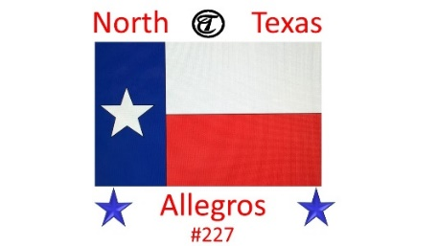
April Rally Registration Form
April 16-19, 2026

Coordinator: Sonny & Elisa Bransom Co- Coordinator: John & Cindy Reeves
Location: The Pines RV & Cabin Resort
4069 County Road SE 4250
Mt. Vernon, Texas 75457
Phone: 903-860-2680

Name(s): Cell #:
Address:
City: State: Zip Code:
Email:
Arrival Date: Departure Date:
Number nights Camping: Number in Coach:
Have you already called campground for reservation?
Site #
Rally Registration Fee: $20.00 per person. # of persons____@ $20.00 = $_______
***To be received by April 11 ***
Make check payable to: Elisa Bransom
Mail to: Elisa Bransom, 8305 CR 1009, Godley, Tx 76044
Or pay Zelle to e.bransom@yahoo.com

If any questions please contact Elisa Bransom @ 817-713-8700

